**Course 5 overview**



Hello, and welcome to **Assets, Threats, and Vulnerabilities**, the fifth course in the Google Cybersecurity Certificate. You’re on an exciting journey!

By the end of this course, you’ll build an understanding of the wide range of assets organizations must protect. You’ll explore many of the most common security controls used to protect valuable assets from risk. You’ll also discover the variety of ways assets are vulnerable to threats by adopting an attacker mindset.

**Certificate program progress**

The Google Cybersecurity Certificate program has eight courses. **Assets, Threats, and Vulnerabilities** is the fifth course.

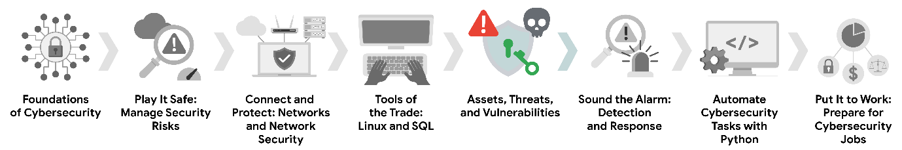

1. [**Foundations of Cybersecurity**](https://www.coursera.org/learn/foundations-of-cybersecurity/home/week/1)
   * Explore the cybersecurity profession, including significant events that led to the development of the cybersecurity field and its continued importance to organizational operations. Learn about entry-level cybersecurity roles and responsibilities.
2. [**Play It Safe: Manage Security Risks**](https://www.coursera.org/learn/manage-security-risks/home/week/1)
   * Identify how cybersecurity professionals use frameworks and controls to protect business operations, and explore common cybersecurity tools.
3. [**Connect and Protect: Networks and Network Security**](https://www.coursera.org/learn/networks-and-network-security/home/week/1)
   * Gain an understanding of network-level vulnerabilities and how to secure networks.
4. [**Tools of the Trade: Linux and SQL**](https://www.coursera.org/learn/linux-and-sql/home/week/1)
   * Explore foundational computing skills, including communicating with the Linux operating system through the command line and querying databases with SQL.
5. [**Assets, Threats, and Vulnerabilities**](https://www.coursera.org/learn/assets-threats-and-vulnerabilities/home/week/1)
   * *(current course)* Learn about the importance of security controls and developing a threat actor mindset to protect and defend an organization’s assets from various threats, risks, and vulnerabilities.
6. [**Sound the Alarm: Detection and Response**](https://www.coursera.org/learn/detection-and-response/home/week/1)
   * Understand the incident response lifecycle and practice using tools to detect and respond to cybersecurity incidents.
7. [**Automate Cybersecurity Tasks with Python**](https://www.coursera.org/learn/automate-cybersecurity-tasks-with-python/home/week/1)
   * Explore the Python programming language and write code to automate cybersecurity tasks.
8. [**Put It to Work: Prepare for Cybersecurity Jobs**](https://www.coursera.org/learn/prepare-for-cybersecurity-jobs/home/week/1)
   * Learn about incident classification, escalation, and ways to communicate with stakeholders. This course closes out the program with tips on how to engage with the cybersecurity community and prepare for your job search.

**Course 5 content**

Each course of this certificate program is broken into modules. You can complete courses at your own pace, but the module breakdowns are designed to help you finish the entire Google Cybersecurity Certificate in about six months.

What’s to come? Here’s a quick overview of the skills you’ll learn in each module of this course.

**Module 1: Introduction to asset security**

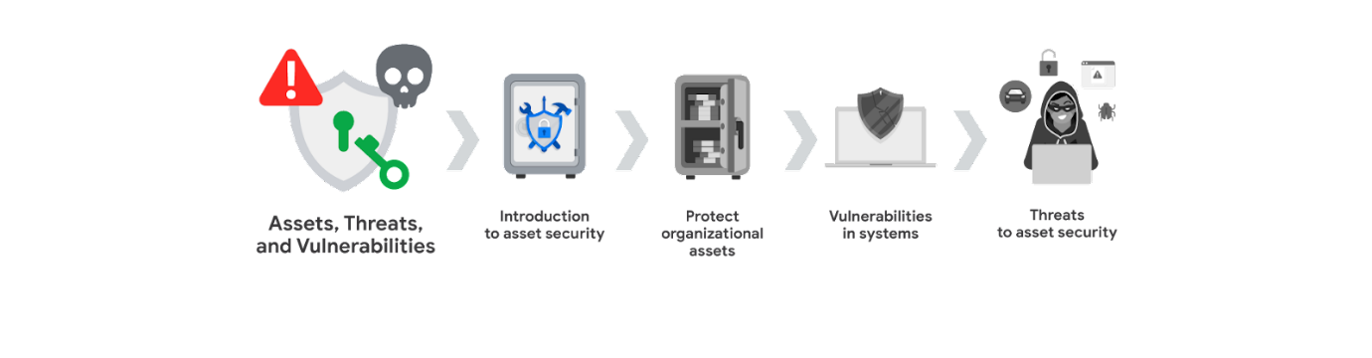

You will be introduced to how organizations determine what assets to protect. You'll learn about the connection between managing risk and classifying assets by exploring the unique challenge of securing physical and digital assets. You'll also be introduced to the National Institute of Standards and Technology (NIST) framework standards, guidelines, and best practices for managing cybersecurity risk.

**Module 2: Protect organizational assets**

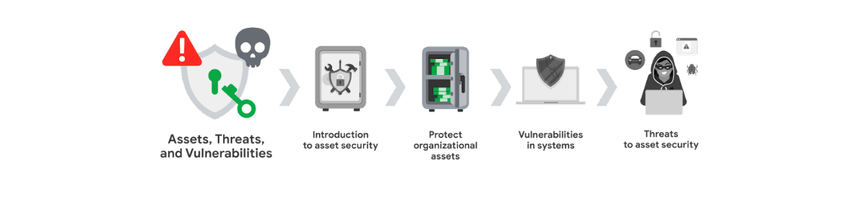

You will focus on security controls that protect organizational assets. You'll explore how privacy impacts asset security and understand the role that encryption plays in maintaining the privacy of digital assets. You'll also explore how authentication and authorization systems help verify a user’s identity.

**Module 3: Vulnerabilities in systems**

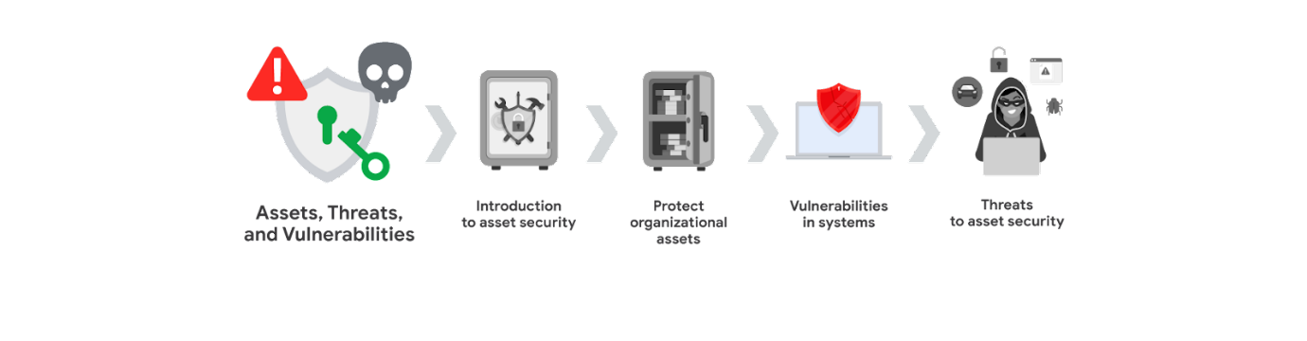

You will build an understanding of the vulnerability management process. You'll learn about common vulnerabilities and develop an attacker mindset by examining the ways vulnerabilities can become threats to asset security if they are exploited.

**Module 4: Threats to asset security**

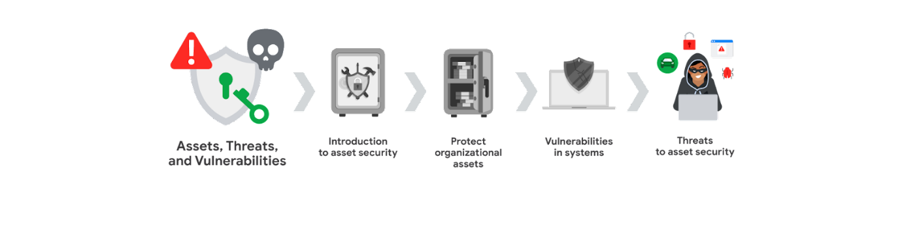

Finally, you will explore common types of threats to digital asset security. You'll also examine the tools and techniques used by cybercriminals to target assets. In addition, you'll be introduced to the threat modeling process and learn ways security professionals stay ahead of security breaches.

**What to expect**

Each course offers many types of learning opportunities:

* **Videos** led by Google instructors teach new concepts, introduce the use of relevant tools, offer career support, and provide inspirational personal stories.
* **Readings** build on the topics discussed in the videos, introduce related concepts, share useful resources, and describe case studies.
* **Discussion prompts** explore course topics for better understanding and allow you to chat and exchange ideas with other learners in the [discussion forums](https://www.coursera.org/learn/assets-threats-and-vulnerabilities/discussions)**Self-review activities** and **labs** give you hands-on practice in applying the skills you are learning and allow you to assess your own work by comparing it to a completed example.
* **Interactive plug-ins** encourage you to practice specific tasks and help you integrate knowledge you have gained in the course.
* **In-video quizzes** help you check your comprehension as you progress through each video.
* **Practice quizzes** allow you to check your understanding of key concepts and provide valuable feedback.
* **Graded quizzes** demonstrate your understanding of the main concepts of a course. You must score 80% or higher on each graded quiz to obtain a certificate, and you can take a graded quiz multiple times to achieve a passing score.

**Tips for success**

* It is strongly recommended that you go through the items in each lesson in the order they appear because new information and concepts build on previous knowledge.
* Participate in all learning opportunities to gain as much knowledge and experience as possible.
* If something is confusing, don’t hesitate to replay a video, review a reading, or repeat a self-review activity.
* Use the additional resources that are referenced in this course. They are designed to support your learning. You can find all of these resources in the [**Resources**](https://www.coursera.org/learn/assets-threats-and-vulnerabilities/resources/4ypPt) tab.
* When you encounter useful links in this course, bookmark them so you can refer to the information later for study or review.
* Understand and follow the [Coursera Code of Conduct](https://www.coursera.support/s/article/208280036-Coursera-Code-of-Conduct?) to ensure that the learning community remains a welcoming, friendly, and supportive place for all members.